Assignment: Using Regression Modeling to predict future Loss Ratio

SevenSprings Insurance consultants observed the following data facts on no. of hospital visits and the overall scheme performance (Loss ratio)

No. of Hospital Visits | Loss Ratio
14 | 92
19 | 82
30 | 60
24 | 72
31 | 58
15 | 90
36 | 48
35 | 50
11 | 98
27 | 66
33 | 54

Using a linear regression to predict below
Planned no. of Hospital Visits | Expected Loss Ratio
45
36

See embedded Excel file herein: (Double Click to Open)

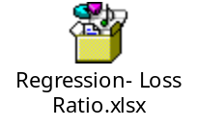

How to undertake a simple regression model using Ms. Excel:
Contents
A. Step 1: Open the Regression model excel worksheet 2
B. Step 2: Activate the Excel Analysis Toolpak Tab on your Excel Application: 2
C. Step 3 Doing your Linear regression 5

Step 1: Open the Regression model excel worksheet

Double click to open the icon below or in the above that has the data.

Step 2: Activate the Excel Analysis Toolpak Tab on your Excel Application:
In your Excel window, select FILE > OPTIONS and ensure you see this window: Under the AddIns Tab, click on the Analytis Toolpak, then click on GO tab below the options window.
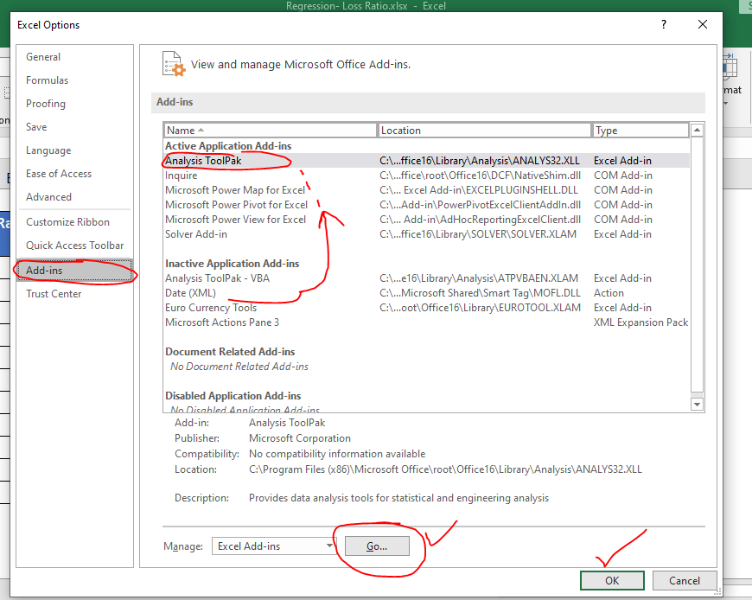
Tick analysis Toolpak on the next window below:
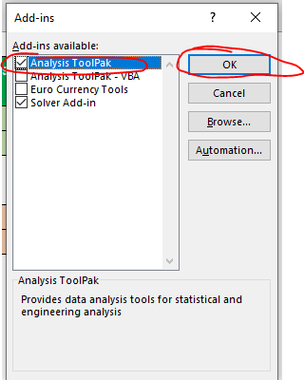
The Data Analysis tab will be activated on your window as below
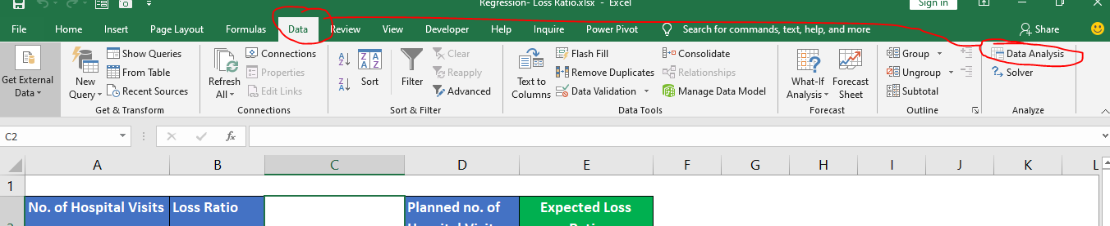

You have activated the Excel Data Analysis Toolpak and ready to undertake your 1st regression model and other statistical analysis.

Step 3 Doing your Linear regression
Navigate to Data>Data Analysis>Regression
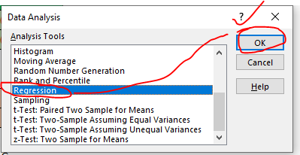

Feed Excel with the data sources: See below – You can zoom the screen to view details clearly (Cell References)
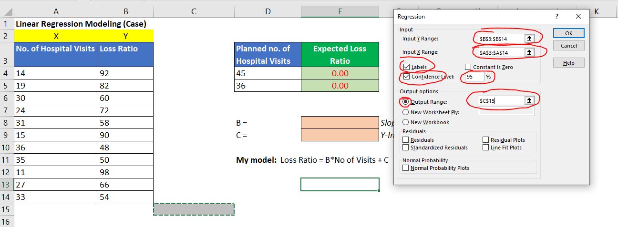

Identify your model coefficients in the workings generated as below:
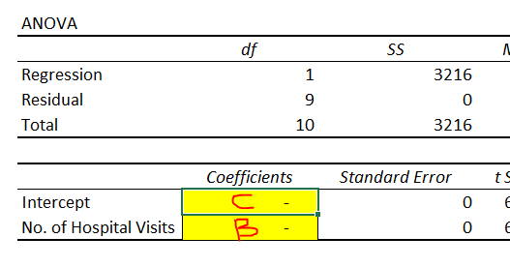

Use these coefficients to fix your linear regression model as follows:

Y = BX + C
Y = Loss Ratio
X = No. of Hospital Visits
B = Slope
C = Y-Intercept
Therefore, your model will be:
Loss Ratio = B * No. of Hospital Visits + C

Apply this equation in the prediction for the following values using the derived coefficients of B and C above – Your X will be the Planned No. of Hospital Visits:
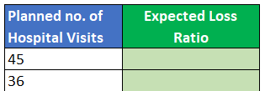
Save the Excel file and upload it back to your Myvarsityglobal account.

